Ex:No: 17

Date:

**HIGH LEVEL PROGRAMMING EXTENSIONS-FUNCTIONS**

**Aim:**

To implement Functions using program in MySQL.

**Functions:**

A function is a subprogram that computes a value.

**Creating a function**

The CREATE FUNCTION statement is also used in MySQL to support UDFs (user-defined functions). A UDF can be regarded as an external stored function.

**MySQL stored function syntax**

CREATE FUNCTION function_name(param1,param2,…)

RETURNS datatype

[NOT] DETERMINISTIC

…..

statements

….

**Problem 1:**

Create a function that returns the level of a customer based on credit limit.

(Use the IF statement to determine the credit limit).

If credit limit > 50000 then customer_level = PLATINUM

If credit limit >= 10000 AND credit limit <= 50000 then customer_level = GOLD

If credit limit credit limit < 10000 then customer_level = SILVER

RECURSION in Mysql Procedures

Mysql version should be >= 5.

Have to set system parameters. This means putting the recursion count limit.

SET @@GLOBAL.max_sp_recursion_depth = 255;

SET @@session.max_sp_recursion_depth = 255;

**Problem 2**

Write a recursive MySQL procedure compute the factorial of a number .

**Program- 1:**

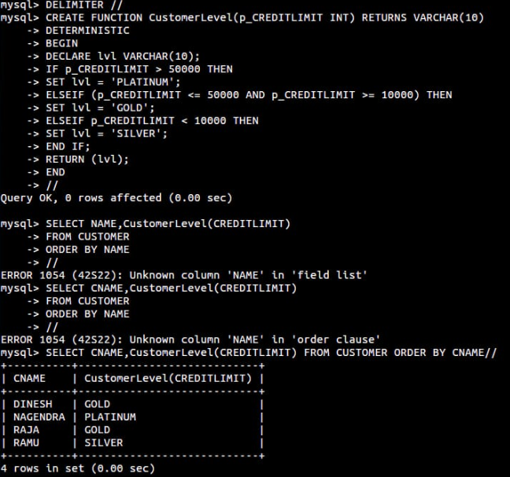



**Program- 2:**

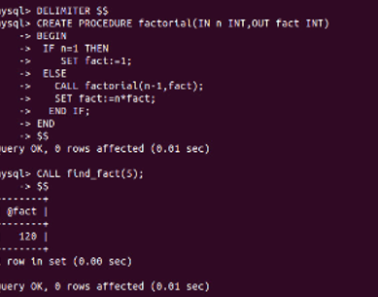

**RESULT:** Thus the Functions using program in MySQL executed successfully .